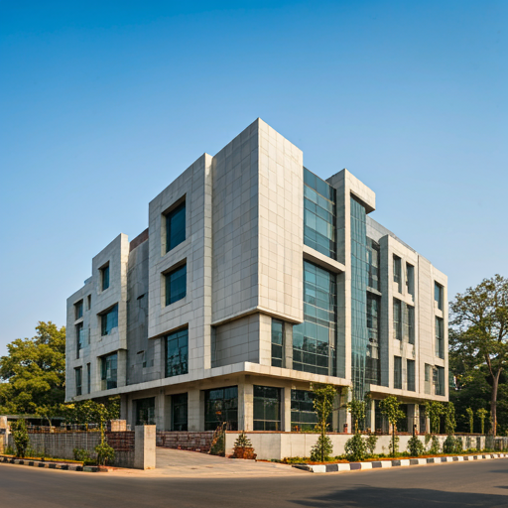

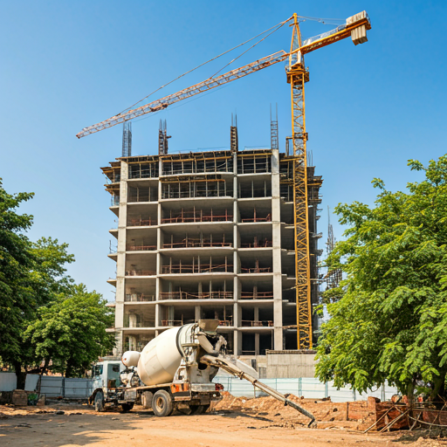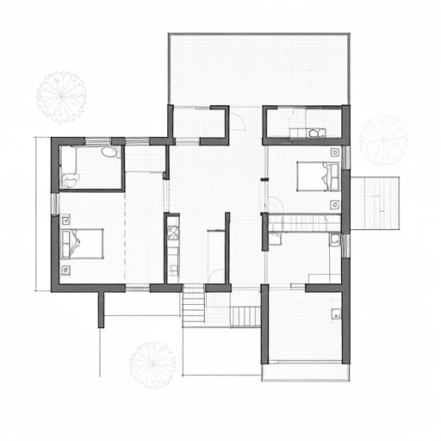

We provide comprehensive architectural & construction services, from initial concept to project completion. Our expertise includes detailed design, structural analysis, and construction management. We are committed to delivering high-quality projects that exceed client expectations. Our services include:

Feasibility studies

Construction drawings

Detailed engineering design and structural analysis

Detailed estimates

Pre-tendering services

Project monitoring and construction



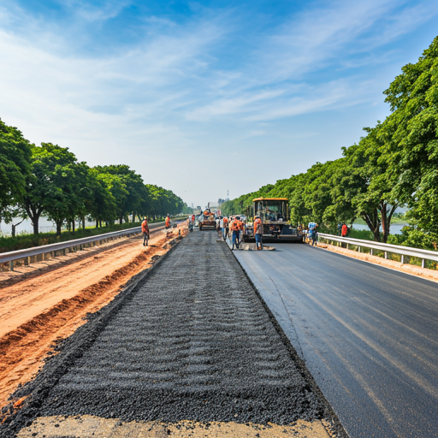

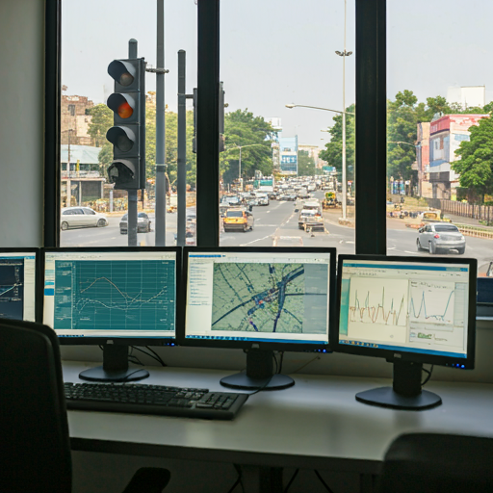

We specialize in comprehensive road and highway engineering services, from planning to construction. Our commitment to safety, reliability, and traffic analysis ensures that our projects meet the evolving needs of transportation infrastructure. Leveraging advanced software and extensive experience, we deliver cost-effective solutions that exceed expectations. Our services include:

Feasibility studies (FS)/Detailed project reports (DPR)

Road and highway construction

Construction supervision (CS)/Independent engineer's services (IE)

Pre-bid and detailed engineering services for PPP/BOT/EPC projects

Lenders engineering services (LIE)

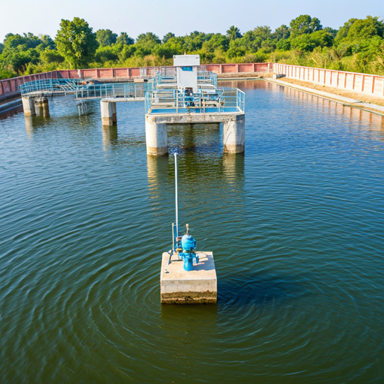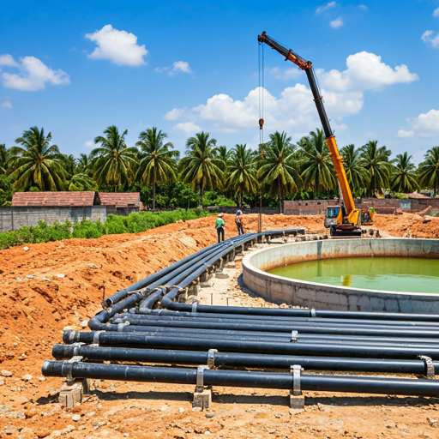

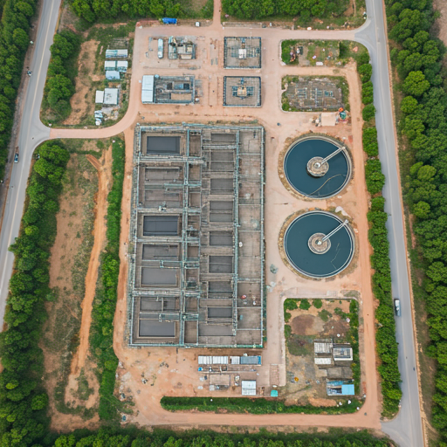

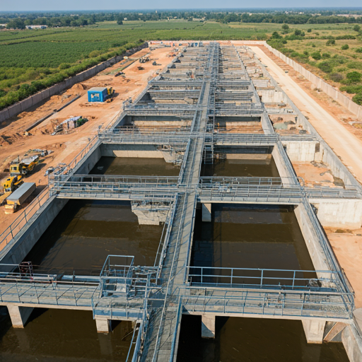

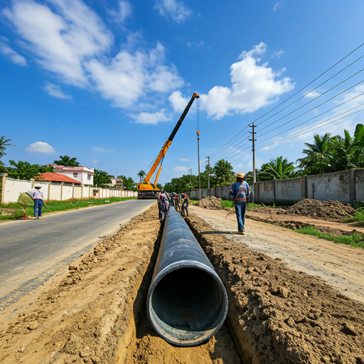

***Environmental Engineering Services:***

Water Supply Systems: Design and implementation of pipe water distribution networks, water treatment plant (WTP) process design, and associated infrastructure.

Wastewater Management: Design and implementation of sewerage conduit lines, sewage treatment plant (STP) process design, and faecal sludge treatment plant (FSTP) process design.

Water Resource Management: Water body rejuvenation and conservation initiatives, including lake and river restoration studies.

***Engineering and Project Management Services:***

Construction Services: Execution of construction works related to all environmental engineering projects, ensuring adherence to quality standards and timelines.

Planning and Design: Preparation of feasibility reports, detailed project reports (DPRs), and detailed engineering services to support project development.

Project Management: Provision of comprehensive project management unit (PMU) services, including project development and management consulting (PDMC) and project management consultancy (PMC).

Quality Assurance: Implementation of rigorous construction supervision and quality control (CS&QC) measures, along with third-party inspection, monitoring, quality assurance, and control (TPQA&C) to ensure project excellence.